Century Snacks LLC Issues Allergy Alert On Undeclared Milk, Soy, Wheat and Cashews in Snak Club Family Size Tropical Trail Mix
May 18, 2018
Director of Food Safety and Quality,
Tony Palacios, 323-278-9578 x427
Century Snacks of Commerce, CA, is recalling certain 16 OZ. bags of Tropical Trail Mix because they may contain milk, soy, wheat and cashew allergens and this is not declared on the package. Individuals who have an allergy or severe sensitivity to milk, soy, wheat or cashews run the risk of serious or life-threatening allergic reaction if they consume these products.
Tropical Trail Mix was distributed to retail outlets throughout Alabama, Arizona, California, Colorado, Florida, Georgia, Illinois, Minnesota, Missouri, Mississippi, North Carolina, New Hampshire, New York, Ohio, Pennsylvania, South Carolina, Texas, Virginia and Washington.
The affected packages of 16 OZ. Tropical Trail Mix have UPC number, 0-87076-64462-8, with lot code “BEST BY DEC 27 2018 TP3B T” printed on the front of the package. The Tropical Trail Mix bags may contain Yogurt Trail Mix inside the bags.
Century Snacks believes this is an isolated incident, due to an error by our packaging supplier, involving a very small quantity of incorrectly filled Tropical Trail Mix bags. No illnesses or adverse reactions have been reported to date.
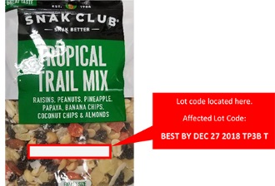
This is an example of a package of Tropical Trail Mix and the location of the lot code.

